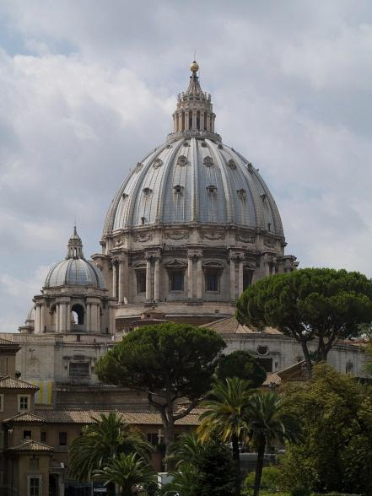
CUA in Rome Spring 2014

Dates
Spring 2014: January 10 - May 4, 2014
Priority Application Deadlines: Oct. 1 (spring), March 1 (fall)

Courses
Visiting Faculty: Dr. Brian Engelland, Business & Economics

ITAL: Italian Language, all levels, 1 or 2 courses
MGT 362 International Marketing
MGT 301 Ethics in Business and Economics
MGT 340 The Spirit of Enterprise: Commerce, Culture and Catholicism Through the Ages
CLAS 206R Roman History
CLAS 318 / ART 318 Art & Architecture of Ancient Rome (HUM distribution)
ENG 378 Italy in American and British Literature
PHIL 310 Philosophy of Art (Area I)
POL 343 Contemporary Italian Politics
TRS 321 The Papacy & the Unity of the Church
TRS 345 Liturgical Art & Architecture
GR 566R Greek Tutorial
LAT 566R Latin Tutorial

Meals & Housing
Students are together in a modern dormitory facility at the CUA Rome campus. Wireless internet, as well as a computer lab and library, is available within the same building. During the spring, host families may also be available. A partial meal plan of 60 euros/week and a local transportation pass are both included in the program price.

Program Trips
In-class site visits around Rome
2 three-day excursions (ex. Siena, Assisi, Naples, Sorrento)
Optional excursions (ex. Venice, Florence, Assisi, Castelli Romani)
10-day break each semester

Costs
$100 Application Fee
$5,000 Administrative Fee
$19,000 CUA Tuition*
*All grants, loans, and scholarships except work-study apply. Additional CUA scholarship opportunities are available for Honors students, Italian Studies minors, and students of diverse backgrounds.

Getting Started
Education Abroad 101: Every Monday-Wednesday at 4:00 in McMahon 111
Rome program Info Session: Thursdays at 4:00 in McMahon 111.
Contact: Education Abroad Advisor Grace Schneider, schneiderg@cua.edu.

